JQuery Assignments:

1. Write a small program to create a table and highlight a table row (except header) on mouse hover as show below:

Note: Table header should not get highlighted on mouse hover 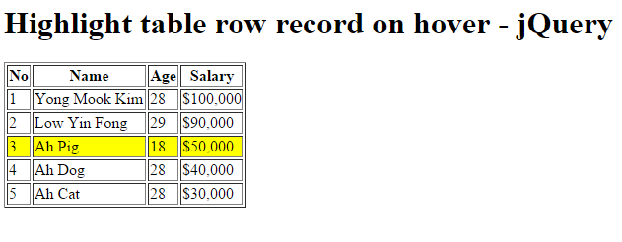

1. Create a table, use maroon color for header and using proper selector add coral and white

color zebra stripes to it.

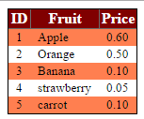

1. Write a program to create a tooltip as shown in diagram below:

* Tooltip gets displayed when mouse is over label ‘username’ and ‘hint’
* Tootip is removed or is not displayed when mouse is over textbox
* Tooltip changes position depending upon whether mouse is over username or hint.

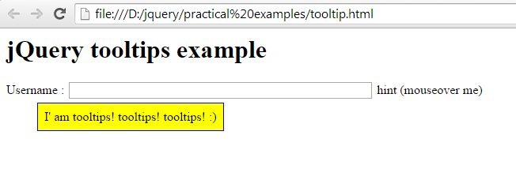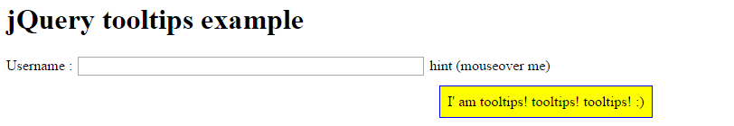

1. There is a small paragraph with 4 lines. Write a simple program to toggle highlight for mouse click on any of lines of the para.

For e.g.: when I first click on line 2, it gets highlighted as shown below, when you click on it again highlight is removed.

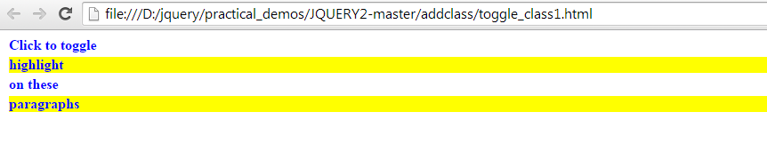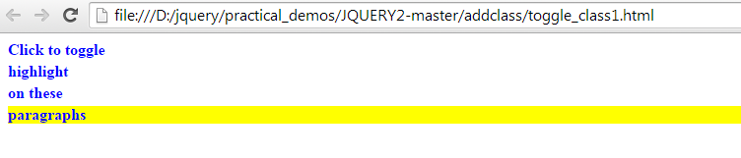

1. Write a program to display value selected in ‘single select’ and ‘multiple select’ list as shown below. Whenever selection changes the values at the top should be updated accordingly.

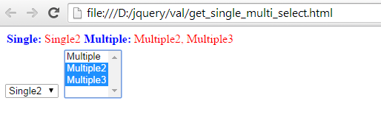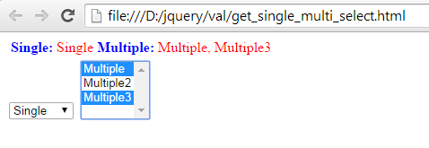

1. Based on ‘delegated-events ‘and ‘event-bubbling’ concept from ‘jQuery’ do following example:

* Create a paragraph ‘Click me’ as shown below. When you click on paragraph ‘click me’, a new paragraph ‘Paragraph 1’ gets added dynamically.
* When you further click on ‘Paragraph 1’ then ‘Paragraph 2’ gets added dynamically as shown below.
* Use ‘On’ event handler to bind click event with ‘body’ instead of ‘paragraphs’ (reason – read ‘delegated events’ and ‘event bubbling’)

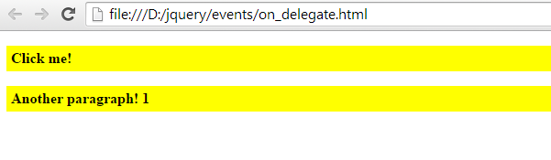

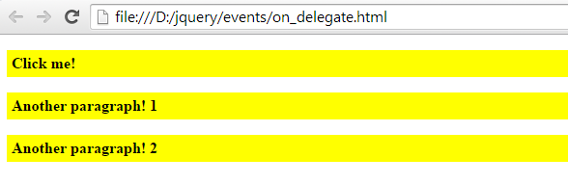

1. Using $(p).each() function of jQuery do following example as shown below:
   * When you go on clicking on each line of the para then for 3 and all its multiples, the line gets highlighted in red.
   * Line also shows no. of clicks performed on it.

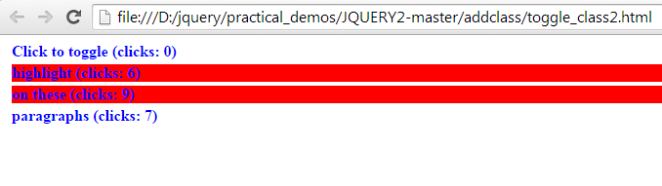

1. Write a program using Dom manipulation function wrap-unwrap to get the output as shown below:

Before click on button: wrap/unwrap

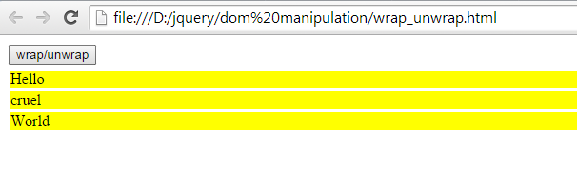

After click on button: wrap/unwrap

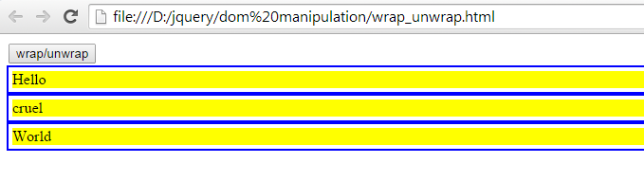

In the same example, which Dom manipulation function you would use to get below output:

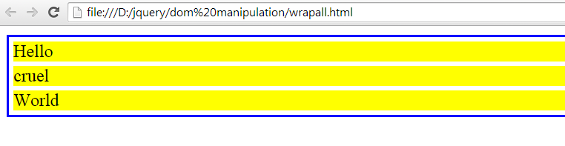

1. Use proper selector to get below output:

Blank cells in yellow color, non-blank cells in pink color.

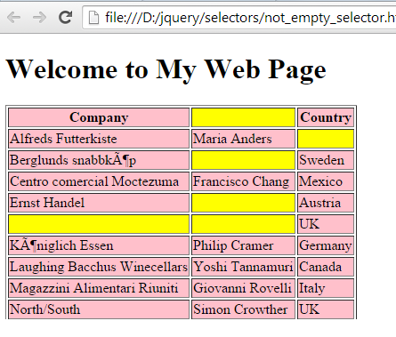

1. Use one event to count clicks done on squares below.

* Each square can be counted only once even if you click multiple times on it.
* So that if you click on each square there would be 5 total clicks for 5 squares as shown below.

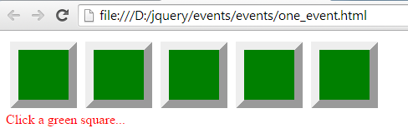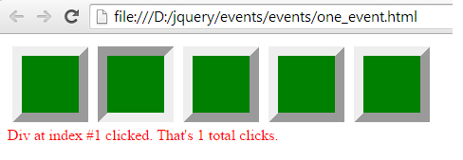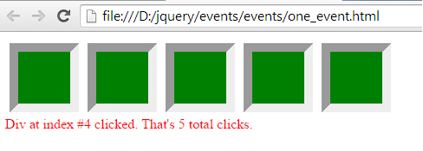

1. Write a program to count no. of checkboxes checked as shown below.

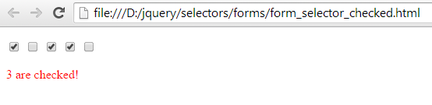

1. There is a hyperlink to w3schools website. When you click on link it opens w3schools web page. But suppose you don’t want the link to open when clicked. Which method of JQuery would you use to prevent this default handling of hyperlink.

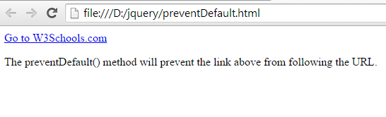

1. <p id="test">This is some <b>bold</b> text in a paragraph.</p>

<p>Name: <input type="text" id="test1" value="Mickey Mouse"></p>

Write a program to show the text inside paragraph ‘test’ in a message box.

Write a program to show the html inside paragraph ‘test’ in a message box.

Write a program to show the value entered inside input box in a message box.

For e.g.: you get following output when you click on ‘Show HTML’ button.

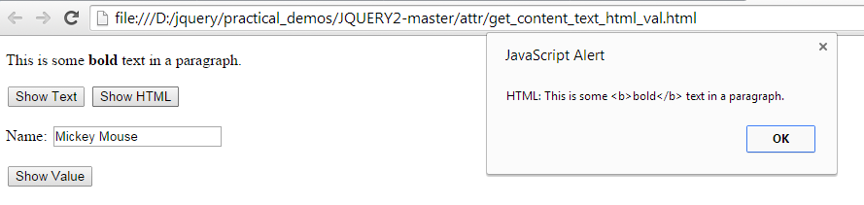

1. Following is json object on server on file data.json.

[

{

"company" : "Toyota",

"product" : "Prius",

"color" : [

"white pearl",

"Red Methalic",

"Silver Methalic"

],

"type" : "Gen-3"

},

{

"company" : "Toyota",

"product" : "New Fortuner",

"color" : [

"Super White",

"Silver",

"Black"

],

"type" : "Fortuner TRD Sportivo Limited Edition"

}

]

* Write a program using jquery on client side to access ‘data.json’ from server using $.getJSON() and show the result of car details using $.each() as shown below.
* When clicked on button ‘Car’ it accesses ‘data.json’ from server and shows car details on screen as shown below:

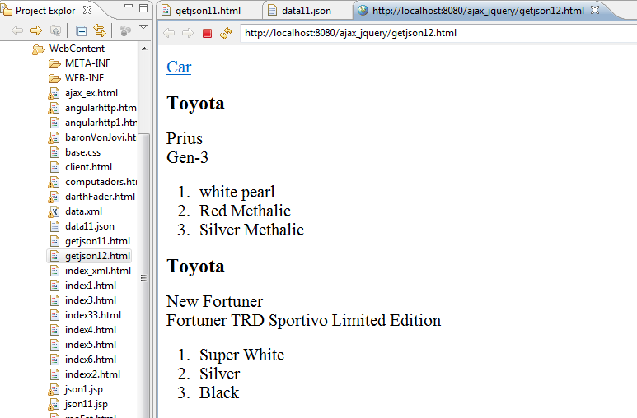

1. Following is ‘name.jsp’ page on server

<%@ page language=*"java"* contentType=*"text/html; charset=ISO-8859-1"*

pageEncoding=*"ISO-8859-1"*%>

<!DOCTYPE html PUBLIC "-//W3C//DTD HTML 4.01 Transitional//EN" "http://www.w3.org/TR/html4/loose.dtd">

<html>

<head>

<meta http-equiv=*"Content-Type"* content=*"text/html; charset=ISO-8859-1"*>

<title>Insert title here</title>

</head>

<body>

My details:

<b>My name is: <%=request.getParameter("myname") %> </b>

<b>My surname is: <%=request.getParameter("surname") %> </b>

</body>

</html>

* Write a program on client side using jQuery - $.get() method to access ‘name.jsp’ page and show result as shown below.
* Pass request parameters as follows:

myname = ‘Namrata’

surname= ‘Marathe’

